
Maize Analytics

In-Depth Settings Guide

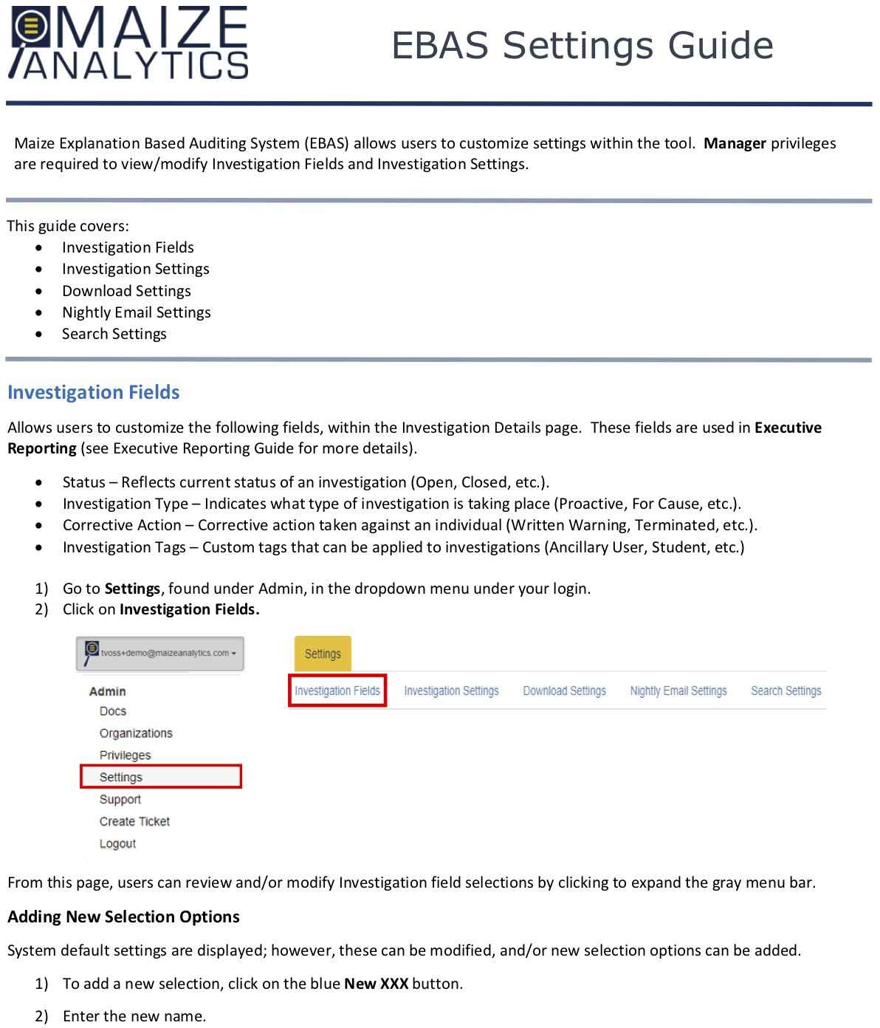

lANALYTICS EBAS Settings Guide
MAIZE

a. lf entering a new status, you will also be required to indicate if the status will be used for an investigation that is Open, ensure the "Treat this Status as an open investigation" box is checked. lf the status will be used for an investigation that is closed, ensure the box is not checked.
- lf you would like the new status to appear in the Status drop down box, on the lnvestigation Details page, make sure to check the "Is active" box.
Note: Status selections cannot be deleted, in case they have been used in historical investigations. lfyou no longer want a status selection to be used (appear in the Status drop down selections), ensure the "Is active" box is not checked.
- Click Save to complete.

Editing Existing Selection Options
- To edit an existing selection option, click on the blue Edit button to the right of the selection.
- Click in the Na me field, if you would like to modify the name.
  - lf editing an existing status selection, you ca n modify if the status wił I be used for an investigatio n that is Open, ensure the "Treat this Status as an open investigation" box is checked. lf the status will be used for an investigation that is closed, ensure the box is not checked.
- Check/uncheck the "Is active" box as applicable.
Note: Status selections cannot be deleted, in case they have been used in historical investigations. lfyou no longer want a status selection to be used (appear in the Status drop down selections), ensure the "Is active" box is not checked.
- Click Save to complete.

lnvestigation Settings
Allows users to modify or upload Breach Risk Determination documentation, set default reporting days and create Reviewer email content preferences for their organization.
- Breach Risk Determination Documentation
- Reviewer Email Template
- Default Reporting Required Days {State, Federal, Media, Patient)

- Go to Settings, found under Admin, in the dropdown menu under your login.
- Click on lnvestigation Settings.

se ings

lnvestigalion Fields lnvestigationsettings Download Settings Nightly Email Settings searcll setlings

© Maize Analytics info@maizeanalytics.com Phone 615.997.0101 x 2 Duplication or distribution of this document, without Maize Analytics' expressed consent, is prohibited.

lANALYTICS EBAS Settings Guide
MAIZE

Risk Assessment Document
Users can review/modify Maize Analytics' Breach Risk Assessment document or upload their own documentation for breach reporting determination.
- To review current documentation, click on the link next to Currently. Documentation will be downloaded and will appear on the bottom left of your screen.

lnvestigation Se tings
Specify investigation preferences for your organization.

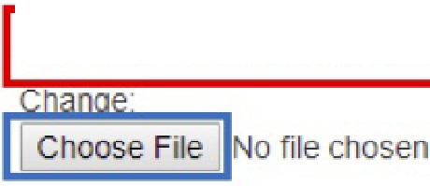
Risk assessment document
Currenlly: intemal/investigateJńsk_assessemenVBreach_Risk_Assessment_ Ef1-UAOR xls
O Clear

Note: Maize provides a Word document or an Excel spreadsheet that contains a Risk Scoring worksheet, in addition to the risk assessment on breaches of unsecured protected health information {PHI) found in the Microsoft Word version. Ask your Maize Account Manager for mare information.
- To upload your own documentation, click on Choose File.
- Click on the document you want to attach from the selection window and click Open.
  - The file name will appear to the right of the Choose File button.
- Click Save to confirm change.
  - The new file name should be reflected as the Currently used documentation.

Reviewer Email Template
Users can create eustom email content, that will be sent to Reviewers, when asked to participate in an investigation.
IReviewer email template j
Hello,

The Compliance team is currently reviewing an access thai requires your input.

Please click on the following link to review investigation • ({ instance.base_ur1 }}{% ur1 "issue_review_reviewe •issue_id %}

Additional inforrnation on the review process can t>e found at: https:J/s3.amazonaws.comfwww.maizeanalytics.com/Reviewer_Guide.pdf

lf filled in. the content in the text field above will be sent Io rev1ewers via email when they are first added to an investigation. HTML is not accepted. To a<ld a linK to the 1nvestigat1on, click here.
To add a linle to me Rev1ewer Guide. cllck here.

- Content to be included in the Reviewer Email Template can be typed in or copy/pasted from another source.
- To include a direct link to the investigation, click here next to "To add a link to the investigation, click here."

© Maize Analytics info@maizeanalytics.com Phone 615.997.0101 x 2 Duplication or distribution of this document, without Maize Analytics' expressed consent, is prohibited.

lANALYTICS EBAS Settings Guide
MAIZE

  - You can also include internaI links to your policies.
- To add a direct link to the Reviewers Guide, click here next to "To add a link to the Reviewers Guide, click here."
- Click Save to confirm changes.

Example Email Content

Greetings Manager,
The compliance team has identified an access, by one of your employees, that represents a potentiaI HIPAA violation(s) related to "need-to-know".
Steps for logging in to view this access investigation and providing feedback are included in the Reviewer Guide: Link included here
The link to the investigation(s) is located here: Link included here
Plea se assess whether the access in this investigation is related to this employee's need to know. lf any access appears suspicious or inappropriate to you, plea se leave a comment for further review by the compliance team.
Feel free to contact us at "email address" if you need assistance in interpreting the attached access investigation or if you have any further questions.
Thank you for your help in assuring we meet the requirements of the Health lnsurance Portability & Accountability Act.

Thanks!
Compliance Team

lnvestigation Reporting Days (Default Values)
The HIPAA Breach Notification Rule requires HIPAA covered entities and their business associates to provide notification to individuals, the Secretary, state entities, and, in certain circumstances, to the media.
Default reporting days can be auto-populated on the lnvestigation Details page. These reporting days, combined with the Date of Discovery (date investigation is created), will auto-calculate Reporting Due dates (if applicable).
Note: Reporting days can be modified on the lnvestigation Details page for investigation specific reporting requirements.

SloJte ilttomey genu.Jl l'l'portlng aaivs St.J1e r1pon1ng Clays detauu
30

Fl-dtral r1-port1ng days dttJUlt

365
Media raporuna Clays detault

120

PJllent „ponlng llays O•l Ult

60

60
Ili

- Enter default reporting days in each field or leave blank. Click on Save to confirm changes.

© Maize Analytics info@maizeanalytics.com Phone 615.997.0101 x 2 Duplication or distribution of this document, without Maize Analytics' expressed consent, is prohibited.

MAIZE
lANALYTICS
EBAS Settings Guide

Download Settings
Within the EBAS application, users can download up to 10,000 access events, to a Comma Separated Values (CSV) file. Download Settings are applied across the organization. CSV downloads can be configured to include specific fields from the following pages.
- Search page
  - Search results
- Full Access Info page
  - Unique Patient/User Access Details (Audit Trail of What the User Clicked on for This Patient)
- Explanations / Enhanced Explanations
  - Diagnosis Responsibility
  - Access Action White list
Note: After a CSV file is downloaded, you can import or save the file as an Excel spreadsheet orany other application that accepts the file format.
Download Settings have two columns. The left column includes all fields available for selection. The right column displays fields that are currently selected to include in the download (see following).
  - Hold down your Ctrl key and select or deselect fields you would like to include in your download.
    - Note: lf you do not hold down the Ctrl key, clicking on a field will deselect all fields. lf this happens you can click the Reset to Default button to return to the default settings.
  - Once fields are selected, click lnclude Selected. Fields selected will be displayed in the Download will lnclude column.

Download Settings
Select data elements you would llke to lnclude In your download by cllcklng the field name(s) Download wlll lnclude:

AddIUonal Data Encounter Oetalls Document Access T)'pe Syslem from Access IPAddress
Access Ac11011
Fun limes Oata Field UserlD PatientlD
Oatemme
user Depanment
User Empłoyee Narne user First Name User Lasł Name
user Do User Profile- user Wtiitelist User Address
user Ne1ghb0r
F@@iii@FIMid i!F

Add11JOnal Dala Encounter Detal Document Access Type system F1om Aecess
lp Addless AecessAcllOO FunTmes Dala field User Id Patientld Date./Time
Number Appropnate Exptanauons (Clinleal Or OperallOOal Reason) Number Flaooecl ExDlanat10ns (Met „

© Maize Analytics info@maizeanalytics.com Phone 615.997.0101 x 2 Duplication or distribution of this document, without Maize Analytics' expressed consent, is prohibited.

lANALYTICS EBAS Settings Guide
MAIZE

Organization Logo
Organizations can upload their logo to appear on downloaded Portable Document Format (PDF), within the EBAS application. PDF downloads, which contain the uploaded logo, will reflected from the following pages.
- Search page
  - Search results
- Reporting and Analytics
  - Executive Reporting

Note: The Maize Analytics logs is the default logo included (see following).
rChoose FIie lNo Ole chosen
org,3nl2Jtlon Logo
Curr•nt Logo:
/ANALYTICS
MAIZE

- To upload your organization's logo, click on Choose File.
- Click on the logo you want to attach from the selection window and click Open.
  - The file name will appear to the right of the Choose File button.
- Click Save to confirm change.
  - The new logo should be displayed under Current Logo.

Nightly Email Settings
You can opt to receive a nightly summary email with saved search results. Search titles are never sent via e-mail, in case they contain protected health information.
- Click the Send Nightly Saved Search Digest check box to receive emails.
- Click Save Settings to confirm.

Explanation-Based Auditing
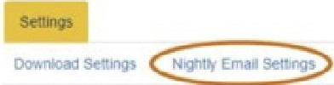
Nighlly Email Settings

lnfol'!mali.aral)'1lc5.com

EBA! Apps
casnooa,"

RepofW,gaM.A.nal'i,11CS

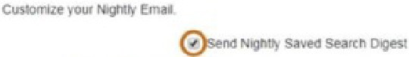
uu,...
..
,..

Admin
Con
OIV>"R1l!IOM

,

© Maize Analytics info@maizeanalytics.com Phone 615.997.0101 x 2 Duplication or distribution of this document, without Maize Analytics' expressed consent, is prohibited.

MAIZE

lANALYTICS
EBAS Settings Guide

Search Settings
Allows users to configure the display order of User and Patient information, within the Full Access Info page (displayed on bottom of page).
Note: Fields displayed in both the User and Patient Info boxes, may not be fields available at your organization. This list is an all-inclusive list of fields. Only user and patient information received from your organization will be reflected in the Full Access Info page.
- Drag and drop fields, within the User Info or Patient Info columns, to change the display order.
- Click Save to confirm change or Reset User Ordering/Reset Patient Ordering to use default settings.

Search Settings
Orag ano crop 10 Cllall!lf Ol'Ce"'tl or eo.er Pauent or inro

User In o Sort Order Patienl Info Sort Order
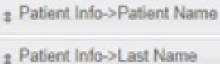
1 Pa lo'lo- Id
I Erndo,.. lnlo-> M Nolno
1 Effll>b, lnb->l..MI ame

I Pał.arl in'lo,,),fnt t,Li

I &npo,,M lnlo->Oob

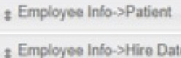
11\łc>->l«I
t Po
1 Pot..-1lnio->Vip
I E,npg,,oo lnie>->Tl1le

I Erndo,oo lnłc>->Floo,

ł Empi,,, ->l•m Oot&
I Ernpb,M l...,_>Ro>góon

I &npr,:,,eo lnlo,>l'mflo

Inio->, 1 "1
I
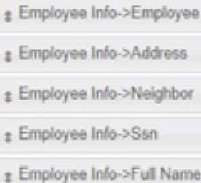
I Empb,N lnlo,>Eą6,yM Id
lnio->Prolil•

1 P:i IM(IJV. nilU
ł PH

1 Pa IMD->P
1 Por 11\io->"-lghbo,
I PalMt lnlo->Son

1 Por.,. IMG->Floo,

I E,npb/ao lnlo,>l'ar- I.., I empc,,. lnlo.>Oig

© Maize Analytics info@maizeanalytics.com Phone 615.997.0101 x 2 Duplication or distribution of this document, without Maize Analytics' expressed consent, is prohibited.

